**Chapter 4: Project Implementation**

**4.1 Introduction** This chapter presents a comprehensive review of the project implementation phase of the Electronic E-commerce Website. Specifically, it outlines the development of key components such as the user interface, back-end functionality, and the flow of screens and modules throughout the system. Important features—including user registration, product browsing, cart management, order processing, and the admin dashboard—will be discussed in detail. Each feature will be supported with relevant code snippets, user interface screenshots, and technical explanations to demonstrate how the system meets the project’s objectives.

A significant component of the platform is the dashboard, which provides administrators with a centralized control panel to manage products, view user activity, track orders, and analyze sales data. This feature enhances the overall efficiency and oversight of the e-commerce operations.

The purpose of this chapter is to demonstrate how the web-based system was designed and implemented to streamline the online shopping experience for customers while providing robust administrative tools for back-end users. The implementation highlights include a responsive design, secure authentication, real-time database connectivity, and a clean, intuitive user interface—ensuring a seamless and effective digital commerce solution for the electronics and IT gadgets industry.

4.2 Features of System  
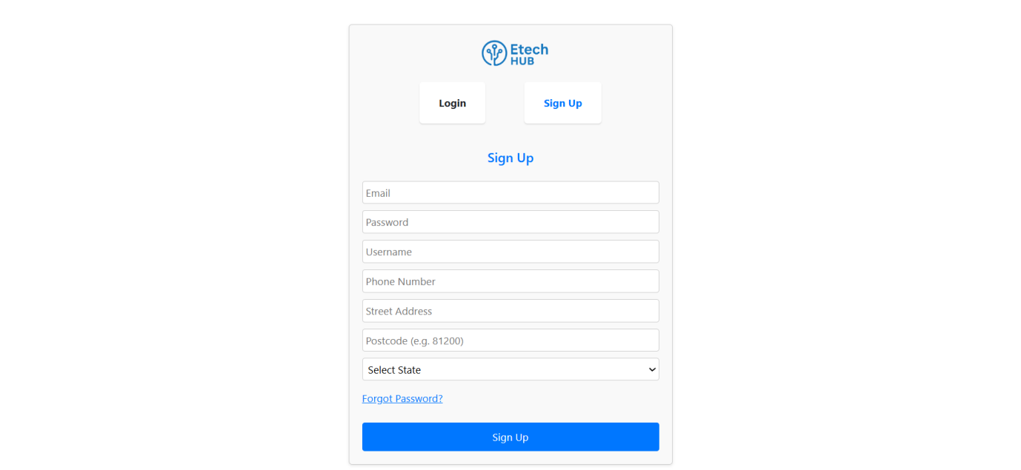 **Figure 4.1 Sign Up** The Sign-Up interface of the E-tech Hub e-commerce platform was designed with user experience and clarity in mind. As shown in Figure 4.1, the screen presents a clean and centered registration form that allows new users to create an account by entering essential details such as email, password, username, phone number, street address, postcode, and state selection via a drop-down menu. The interface also includes navigation tabs that enable seamless switching between the login and sign-up views. A “Forgot Password?” link is provided for account recovery, enhancing usability and user support. The form submission is handled with validation and real-time feedback to ensure data accuracy and security. This screen plays a critical role in on-boarding new users into the platform, enabling access to personalized shopping, order tracking, and cart management features. The implementation was done using React.js for the front-end and is integrated with Firebase Authentication for secure and scalable user management.